Bank Statement
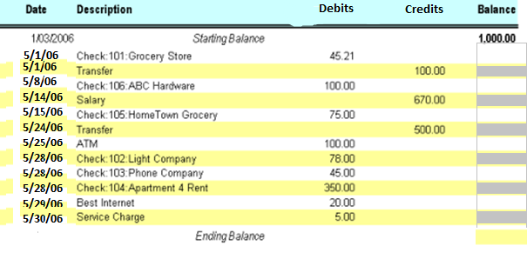
Check register
 | date | description | debit | credit | New Balance
 |  |  |  |  | 1,000.00
101 | 4/25/06 | Groceries | 45.21
 | 5/1/06 | Transfer cash |  | 100.00
102 | 5/2/06 | Electric Co | 78.00
103 | 5/2/06 | Phone co. | 45.00
104 | 5/2/06 | Rent | 350.00
105 | 5/2/06 | Groceries | 75.00
 | 5/3/06 | Paycheck |  | 670.00
106 | 5/5/06 | ABC hardware | 100.00
107 | 5/15/06 | Dinner | 48.24
108 | 5/20/06 | Auto Repair | 284.26
 | 5/24/06 | Transfer |  | 500.00
 | 5/25/06 | ATM | 100.00
 | 5/26/06 | Computer Rebate |  | 100.00
debit | 5/29/06 | Best internet | 20.00
ATM | 5/30 | Withdraw Cash | 80.00
 | 5/30 | Service Charge | 5.00

check | amount
Ending Balance shown on statement____________
Plus Deposits NOT shown on this statement___________
Sub Total___________
Less Outstanding checks___________
Adjusted Ending Balance___________

